ASSESSING ASTHMA CONTROL IN EUROPEAN CHILDREN

Significant and Unacceptable Differences Among Countries

SYSTEMATIC REVIEW

Campos, Patrícia (mimed09113@med.up.pt); Ferreira, Diana (mimed09031@med.up.pt); Grade, Carlos (mimed09246@med.up.pt); Martins, Sara (mimed09179@med.up.pt); Reina, Sara (mimed09165@med.up.pt); Santos, André (mimed09230@med.up.pt); Santos, Joana (mimed09053@med.up.pt); Santos, Joaquim (mimed09019@med.up.pt); Serra, Maria João (mimed09021@med.up.pt); Silva, Diana (mimed09028@med.up.pt); Silva, Patrícia (mimed09115@med.up.pt).

Head Teacher: Prof. Dr. Altamiro da Costa Pereira
Advisor: Prof. Dr. João de Almeida Lopes da Fonseca and Luís Miguel Ribeiro Nogueira Soares Da Silva
Class: 19 (fmup.turma19@gmail.com)

ABSTRACT
Introduction - Asthma is characterized by an inflammation in airways, which, when uncontrolled, can place severe limits on daily life and is sometimes fatal. This chronic disease appears to be increasing more in younger than in older children, since 48.7% of hospital admittances with asthma were patients aged under nineteen years old. Knowing the percentage of controlled children is essential to understand the need to inform and help people to control the disease.
Aims – This systematic review aims to understand what the proportion of asthma control is, in European children.
Methods – The study design of our article is that of a systematic review based on observational studies performed on asthmatic European children (aged between zero and eighteen years old). Through a query we intend to search and select articles, basing on exclusion and inclusion criteria, in order to obtain a number of studies containing quality information on proportion values.
Results – We didn’t expect to find great differences between proportion values in European countries. However, after analyzing 6 articles we found that not only the values were different between countries, but also referring to the same country the results were contradictory. Regarding Spain, 15% of children show controlled asthma against proportion values of 70% when it comes to a separate study. The two Dutch articles reflect a similar pattern about 70% in one and less than 10% in the other. On the study reporting Switzerland and Germany together, around half of the participants included in the study are uncontrolled, when in Hungary, 70% are controlled.
Conclusion - After analyzing the results of the different European countries, the main conclusion we can extract is that control of asthmatic children is very distinct among them.

KEYWORDS
Asthma, Control, Children, Europe

INTRODUCTION
Asthma is a serious global health problem. People of all ages in countries throughout the world are affected by this chronic airway disorder that, when uncontrolled, can place severe limits on daily life and is sometimes fatal. The prevalence of asthma is increasing in most countries, especially among children. Asthma is a significant burden, not only in terms of health care costs but also of lost productivity and reduced participation in family life. ^{[1]}
Asthma is characterized by an inflammation in airways. This inflammation has many consequences like wheezing, breathlessness, chest tightness, and coughing. This chronic disease appears to be increasing more in younger than in older children (“Using the Health Services Central Administration data base we reviewed 24271 admissions and saw that 48.7% of patients admitted were aged under nineteen years-old” ^{[2]}). They are more exposed to the disease due to their fragile immune system, and that's why the disease control on this population is crucial. ^{[1] [3]}
From the GINA (Global Initiative for Asthma) guidelines: asthma control refers to control of the clinical manifestations of disease. A working scheme based on current opinion that has not been validated provides the characteristics of controlled, partly controlled and uncontrolled asthma. The symptoms and their frequency that a child must present to be fitted into one of the three categories are explained in Appendix 5. Complete control of asthma is commonly achieved with treatment, the aim of which should be to achieve and maintain control for prolonged periods, with due regard to the safety of treatment, potential for adverse effects, and the cost of treatment required to achieve this goal. ^{[1]}
In children, asthma control can be assessed using questionnaires, such as the Childhood Asthma Control Test (C-ACT). A cross-sectional validation was conducted and the results were a score of 19, which indicated inadequately controlled asthma in children between the ages of four and eleven years old. ^{[4]}
Controlled children have minimal effects of asthma, while children who are not controlled present more complications , and if no action is taken quickly, when the therapy is actually started it will certainly be more difficult to diminish the symptoms and control the disease. ^{[5]}
Furthermore, this disease causes instability on family life of asthmatic children, rising the costs and affecting the family environment. The control of asthma thus gains the necessity to be applied all over the world, being particular for each country and its reality, but obeying to international rules. This way, the fight against asthma should and can be improved and unnecessary deaths can be prevented.
Knowing the percentage of controlled children (aged between zero and eighteen years old) is essential to understand the need to inform and help people to control the disease. That was our motivation to choose the following question:

RESEARCH QUESTION
What is the proportion of asthma control in children in Europe?

AIMS
Our aims are:
- study the proportion of asthma control in European children;
- account for the differences between European countries.

PARTICIPANTS AND METHODS

Study Design
This study is a systematic review, using articles from online databases. Based on the articles obtained and on a qualitative study we will be able to assess the proportion of asthma control in children.
Study participants
The target population of our study are all the observational studies on children (below the age of eighteen years old) resident in Europe, who suffer from asthma.

Data Collection Methods
Data Search
The Data Search Methods which were used include three stages, defined by the students, following a logical stream.
A preliminary research was conducted by three individuals separately, in order to collect the key-words referring to the articles which answered to the research question established. These were the findings: “Asthma”; “Children”; “Europe”; “Control”.
In a second stage, a query for each chosen database was necessary, so the class was divided in three groups: two of four individuals and one of only three. The students worked in their groups to build an effective query, using the key-words previously presented. The Queries used in data search are the ones that follow:
Pubmed: ("Asthma"[Mesh] OR asthm*[tiab] OR "Asthma/prevention and control"[Mesh]) AND (child [MeSH]) AND (europe [MeSH] OR europe [tiab]).
Scopus: TITLE-ABS-KEY ((“Asthma” OR asthm* OR “Asthma/prevention AND control”) AND (child) AND (europe OR european))
Isi Web of Knowledge: Topic=(asthma) AND Topic=(control) AND Topic=(europe) AND Topic=(children)
The third and final stage of the research is the DataBase Search. The chosen DataBases were drawn to each of the previously mentioned groups on February 26th. Each group had from March 1st until March 12th to conclude the research and present the EndNote file containing the articles’ references. This task simply was to export all citations to a reference manager, the one used being EndNote X3^{[6]} since it was easier to work with in order to keep track of articles and remove the duplicates.
The number of articles obtained was 3071 in Pubmed, 571 in Scopus and 27 in Isi Web of Knowledge. Regarding the great number of articles found using Pubmed we decided that only one student was to be responsible for the exportation of Isi’s references, and the remaining three were included in the Pubmed group.
After the removal of duplicates our total number of articles was 3335.

Data Selection
The references were divided, using EndNote, in four files of 830, give or take, which were randomly distributed by four groups of two students each. The groups read the titles and abstracts of the articles, excluding those they believed not to be essential to our review and writing down their motives for such exclusion. In cases of disagreement one of the three colleagues left was consulted.
This process led to a total of 195 included articles and 3133 excluded.
In the next phase, four different groups composed of two students were given 49 of the included articles in order to read, and by applying inclusion criteria: (A) study’s made in children; (B) children being controlled in an European country; (C) definition of asthma control is according to GINA’s guidelines; and exclusion criteria: (1) focusing only the methods of asthma control; (2) not written in English; (3) the study’s result referred to both adults and children combined; (4) it did not measure the proportion of control; (5) the full text was not available; selected the final articles to be included in the study. Similarly, a third reviewer was added, when necessary.
In the end of this phase we had included a total of 6 articles.

However, after the presentation we realized that the number of articles obtained in the three databases were not in accord with each other. For instance:
- Isi’s were too low;
- Pubmed’s were too many in comparison with Scopus’s, since the former is included in the latter.
For these reasons, we decided to create new queries, which are:
Pubmed: (Asthma[Mesh] OR asthma[tiab]) AND (child [MeSH] OR child [tiab]) AND (control)).
Scopus: TITLE-ABS-KEY(asthma) AND TITLE-ABS-KEY(control) AND ABS(child)
Isi Web of Knowledge: Topic=(asthma) AND Topic=(control) AND Topic=(children)
The number of articles thus obtained was 6034 in Pubmed, 4948 in Scopus and 3587 in Isi Web of Knowledge.
In this new attempt, we conducted the same methods as before; only the results changed. So, after removing the duplicates we ended up with 6672 articles and by the end of the Data Selection Phase, we included 6 articles.
The Data Selection Methods are shown in the FlowChart presented in Appendix 1. In Appendix 2 there is a FlowChart illustrating the triage process of the second attempt.

Quality Assessment
This step was performed independently by two reviewers, according to the STROBE checklist^{[15]}, whose Quality Criteria are discriminated in Appendix 3. This specific checklist has a total of twenty-two items.

Title | Author | Score
Cost, morbidity, and control of asthma in Hungary: The Hunair Study | Herjavecz I, N. G., Gyurkovits K, Magyar P, Dobos K, Nagy L, Alemao E, Ben-Joseph R. | 17
Actual asthma control in a paediatric outpatient clinic population: do patients perceive their actual level of control? | Hammer SC, R. C., van Rij C, Heynens J, Droog R, Jöbsis Q, Hendriks HJ, Dompeling E. | 13
Age-related differences in perceived asthma control in childhood: guidelines and reality | Kuehni CE, F. U. | 15
Predictors of the persistence of childhood asthma. | Cabanas Rodriguez ER, G. B. F., Cabanas Rodriguez P, Leis R, Martinez B, Cabanas R, Valdes Cuadrado L, Tojo R. | 13
Women, patients with severe asthma, and patients attended by primary care physicians, are at higher risk of suffering from poorly controlled asthma." | Badiola C, B. L., Plaza V, Prieto L, Molina J, Villa JR, Cimas E. | 17
Predictors of asthma control in children from different ethnic origins living in Amsterdam. | Van Dellen QM, S. K., Bindels PJ, Ory FG, Bruil J, van Aalderen WM; PEACE Study Group. | 16

Data Extraction
For each study selected, a reviewer extracted data to an Excel© ^{[8]} spreadsheet and another one confirmed the information. Data on (I) year of publication; (II) authors of study; (III) type of study; (IV) countries where control was performed; (V) study quality; (VI) response rate; (VII) title of article; (VIII) type of control and (IX) proportion values were extracted from original articles and reunited.
The information was afterwards compiled in an SPSS Syntax by a single student. The variables to be created were previously discussed and the syntax created by three reviewers working together.

Data Processing
Using the Microsoft Office Excel’s graph tools, the proportion values were compiled according to the respective country.

RESULTS

The Netherlands
Chart 1: Proportion of controlled/uncontrolled children in The Netherlands. ^{[9]}

Chart 2: Proportion of controlled, partially controlled and uncontrolled children in The Netherlands. ^{[10]}

The information obtained about The Netherlands is incoherent. In one article the proportion of controlled children is higher (about 70%), while in the other that proportion is less than 10%.
Spain
Chart 3: Proportion of controlled, partially controlled and uncontrolled children in Spain.^{[11]}

Chart 4: Proportion of controlled/uncontrolled children in Spain. ^{[12]}

Similar to the contradictious results observed on the two articles from Netherlands, Spain presents two different results. The first chart shows a proportion of 15% controlled children, while the second one has 70%.

Germany and Switzerland
Chart 5: Proportion of controlled, partially controlled and uncontrolled children in Swiss-Germany ^{[13]}

The proportion of uncontrolled children in Swiss –Germany is around 50%, half of the participants included in the study, and only 18/19% of them are controlled.

Hungary

Chart 6: Proportion of controlled, partially controlled and uncontrolled children in Hungary ^{[14]}

This results are very clear, 70% of the children are controlled, against only 3% uncontrolled.

DISCUSSION
With our Systematic Review, we expected to find a great number of observational studies focusing the proportion of asthma control in European children, something that, in fact, didn’t happen. However, the articles found lead us to some interesting but controversial results about the proportion of asthma control in children among the European countries.
Initially, with our Systematic Review, we expected that the articles directly related to our research question and aims would tell us that most asthmatic children in Europe had this disease controlled, but many others didn’t ^{[7], [8]}, so that the need to promote and inform the population about this control was moderate and continuous, but not extremely urgent. Moreover, we thought that the differences of the results encountered between different regions in Europe wouldn’t be very accentuated, since all the European countries are considered developed countries that cooperate to find the best way to guarantee a good quality of life of the European children (which includes an efficient vigilance and care about their health).
However, after analyzing the results of the different European countries, we realized that these were quite different from our expectations - in particular, the expected result of homogeneity is not checked, since there are countries with a high proportion of asthma control and others with a low one and even in the same country, there is account for different values of proportion.
Asthma control can, at least in one of the studies found (Kuehni CE, F.U. 2002), vary according with the age stratum, namely in Germany and Switzerland.
Ergo, it might be interesting to widen the spectrum of studies in this area, given the low number of relevant results.
Anyway, some explanations for poorly controlled asthma may be inadequate parents’ perception of asthma control; the dynamic process of asthma; too little step-up of asthma treatment by the pediatrician; too little instruction on a proper inhaler technique^{[10]}.

LIMITATIONS
While performing this Systematic Review we have encountered various problems in the different phases of our project. The fact that we had to re-do the whole review from scratch just when we had already the final articles is an example of such matters.
Although we had some problems with the queries, which were clearly the reason why our numbers were so discrepant, we solved this by creating new and more effective ones. Such effectiveness is reflected on the more coherent results obtained afterwards on the basis of article number per database; not so much about the core of the project itself.
When it comes down to the conclusions, there is a difficulty in generalizing asthma proportion in European children, since the data collected are very few and different for each country found and even controversial within some countries. Such is the justification why it was not possible to compile the data in one single graph and/or table.
Furthermore, we did prepare for the eventuality of the number of final articles being too low or their results being contradictory by saving the articles which did not have full-text available and by writing an e-mail to be sent to the authors. Yet, we did not send it.
This is justified by a number of reasons. Firstly the time we had saved for this part of the project was totally consumed by the resolution of other problems, previously mentioned. Secondly, comparing the tittles of the saved articles with the ones that we excluded after reading the full-text, we realized that the point of focus might have been similar and, for that fact, the probability of exclusion rose higher. Finally, in order not to neglect the work that needed to be done, we decided that not committing to more articles would be in the best interest of our project.

REFERENCES
^{[1]} From the Global Strategy for Asthma Management and Prevention, Global Initiative for Asthma (GINA) 2008.
^{[2]} Bugalho de Almeida A et al. Asthma hospital admission and mortality in mainland Portugal 2000-2007. Rev Port Pneumol. 2009; 15(3):367-383.
^{[3]} Gelfand EW. Pediatric asthma. A different disease. Proc Am Thorac Soc 2009; 6:278-82.
^{[4]} Liu AH, Zeiger R, Sorkness C, T, N, S, Rosenzweig JC, R. Development And Cross-Sectional Validation Of The Childhood Asthma Control Test. J Allergy Clin Immunol. 2007 apr;119(4):817-25.
^{[5]} Blic J, Deschildre A, Pin I, Dubus Pour Le Grapp JC. When and how to modify the management of asthma in children over the age of 4. Rev Mal Respir. 2009 Oct; 26(8):827-35.
^{[6]} von Elm E, Altman DG, Egger M, Pocock SJ, Gøtzsche PC, Vandenbroucke JP. The Strengthening the Reporting of Observational Studies in Epidemiology (STROBE) statement: guidelines for reporting observational studies. STROBE Initiative. J Clin Epidemiol. 2008 Apr; 61(4):344-9.
^{[7]} Holgate S et al. The Brussels Declaration: the need for change in asthma management. The European respiratory journal: official journal of the European Society for Clinical Respiratory Physiology. 2009; 34(1):290.
^{[8]} Peroni DG et al. Preschool asthma in Italy: prevalence, risk factors and health resource utilization. Respiratory Medicine. 2009; 103(1):104-8.
^{[9]} Van Dellen QM, S. K., Bindels PJ, Ory FG, Bruil J, van Aalderen WM; PEACE Study Group. Predictors of asthma control in children from different ethnic origins living in Amsterdam. Respir Med. 2007; 101(4): 779-785.
^{[10]} Hammer SC, R. C., van Rij C, Heynens J, Droog R, Jöbsis Q, Hendriks HJ, Dompeling E. (). Actual asthma control in a paediatric outpatient clinic population: do patients perceive their actual level of control? Pediatr Allergy Immunol. 2008; 19(7): 626-633.
^{[11]} Badiola C, B. L., Plaza V, Prieto L, Molina J, Villa JR, Cimas E. "Women, patients with severe asthma, and patients attended by primary care physicians, are at higher risk of suffering from poorly controlled asthma." Prim Care Respir J. 2009; 18(4): 294-299.
^{[12]} Cabanas Rodriguez ER, G. B. F., Cabanas Rodriguez P, Leis R, Martinez B, Cabanas R, Valdes Cuadrado L, Tojo R. Predictors of the persistence of childhood asthma. Allergol Immunopathol (Madr). 2008; 36(2): 66-71.
^{[13]} Kuehni CE, F. U. Age-related differences in perceived asthma control in childhood: guidelines and reality. Eur Respir J. 2002; 20(4): 880-889.
^{[14]} Herjavecz I, N. G., Gyurkovits K, Magyar P, Dobos K, Nagy L, Alemao E, Ben-Joseph R. Cost, morbidity, and control of asthma in Hungary: The Hunair Study. J Asthma. 2003; 40(6): 673-681.

Appendix 1: FlowChart – Data Selection Methods
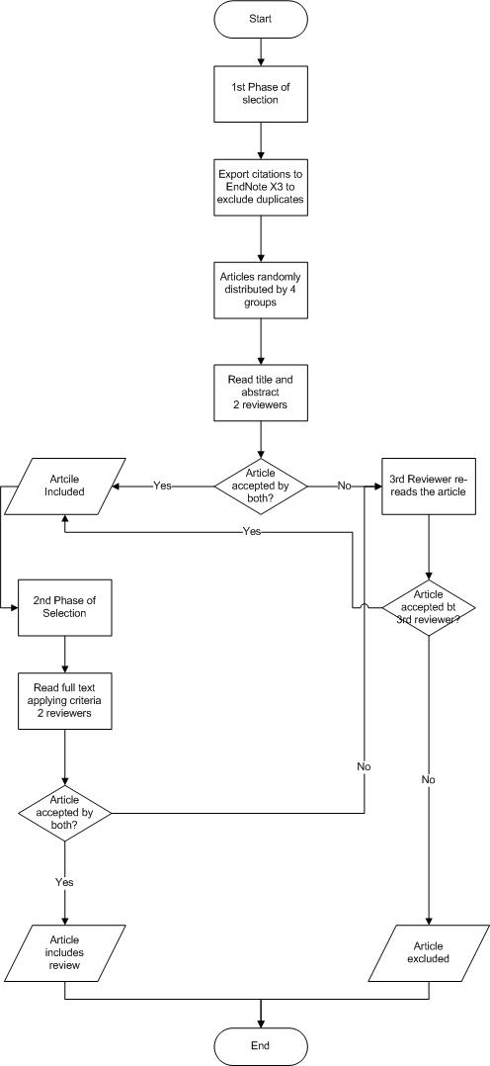
Appendix 2: FlowChart – Data Selection: article numbers
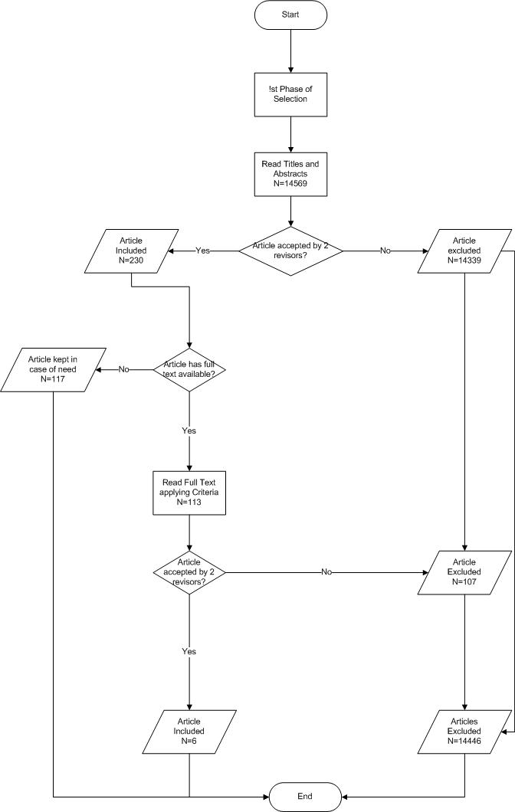
Appendix 3: STROBE Statement—checklist of items that should be included in reports of observational studies
 |  | Item No | Recommendation
Title and abstract |  | 1 | - Indicate the study’s design with a commonly used term in the title or the abstract  - Provide in the abstract an informative and balanced summary of what was done and what was found
Introduction | Background/  rationale | 2 | Explain the scientific background and rationale for the investigation being reported
Introduction | Objectives | 3 | State specific objectives, including any prespecified hypotheses
Methods | Study design | 4 | Present key elements of study design early in the paper
Methods | Setting | 5 | Describe the setting, locations, and relevant dates, including periods of recruitment, exposure, follow-up, and data collection
Methods | Participants | 6 | - Cohort study—Give the eligibility criteria, and the sources and methods of selection of participants. Describe methods of follow-up;  Case-control study—Give the eligibility criteria, and the sources and methods of case ascertainment and control selection. Give the rationale for the choice of cases and controls;  Cross-sectional study—Give the eligibility criteria, and the sources and methods of selection of participants.  - Cohort study—For matched studies, give matching criteria and number of exposed and unexposed  Case-control study—For matched studies, give matching criteria and the number of controls per case
Methods | Variables | 7 | Clearly define all outcomes, exposures, predictors, potential confounders, and effect modifiers. Give diagnostic criteria, if applicable
Methods | Data sources/ measurement | 8* | For each variable of interest, give sources of data and details of methods of assessment (measurement).  Describe comparability of assessment methods if there is more than one group
Methods | Bias | 9 | Describe any efforts to address potential sources of bias
Methods | Study size | 10 | Explain how the study size was arrived at
Methods | Quantitative variables | 11 | Explain how quantitative variables were handled in the analyses. If applicable, describe which groupings were chosen and why
Methods | Statistical methods | 12 | - Describe all statistical methods, including those used to control for confounding  - Describe any methods used to examine subgroups and interactions  - Explain how missing data were addressed  - Cohort study—If applicable, explain how loss to follow-up was addressed;  Case-control study—If applicable, explain how matching of cases and controls was addressed;  Cross-sectional study—If applicable, describe analytical methods taking account of sampling strategy;  (e) Describe any sensitivity analyses
Results | Participants | 13* | - Report numbers of individuals at each stage of study—eg numbers potentially eligible, examined for eligibility, confirmed eligible, included in the study, completing follow-up, and analysed  - Give reasons for non-participation at each stage  - Consider use of a flow diagram
Results | Descriptive data | 14* | - Give characteristics of study participants (eg demographic, clinical, social) and information on exposures and potential confounders;  - Indicate number of participants with missing data for each variable of interest;  - Cohort study—Summarize follow-up time (eg, average and total amount);
Results | Outcome data | 15* | Cohort study—Report numbers of outcome events or summary measures over time  Case-control study—Report numbers in each exposure category, or summary measures of exposure  Cross-sectional study—Report numbers of outcome events or summary measures
Results | Main results | 16 | - Give unadjusted estimates and, if applicable, confounder-adjusted estimates and their precision (e.g. 95% confidence interval). Make clear which confounders were adjusted for and why they were included  - Report category boundaries when continuous variables were categorized  - If relevant, consider translating estimates of relative risk into absolute risk for a meaningful time period
 | Other analyses | 17 | Report other analyses done—e.g. analyses of subgroups and interactions, and sensitivity analyses
Discussion | Key results | 18 | Summarize key results with reference to study objectives
Discussion | Limitations | 19 | Discuss limitations of the study, taking into account sources of potential bias or imprecision. Discuss both direction and magnitude of any potential bias
Discussion | Interpretation | 20 | Give a cautious overall interpretation of results considering objectives, limitations, multiplicity of analyses, results from similar studies, and other relevant evidence
Discussion | Generalizability | 21 | Discuss the generalizability (external validity) of the study results
Other information | Funding | 22 | Give the source of funding and the role of the funders for the present study and, if applicable, for the original study on which the present article is based

*Give information separately for cases and controls in case-control studies and, if applicable, for exposed and unexposed groups in cohort and cross-sectional studies.

Appendix 4: E-mail to be sent to authors of articles lacking full text

Dear sir or madam,
We are First Year Portuguese students, taking a Medical Degree at Faculdade de Medicina da Universidade do Porto and we are sending this e-mail as part of our annual Project of Introduction to Medicine. Our class is conducting a Systematic Review on asthma control in children from different European Countries.
According with the queries we used, your article was one of those we obtained, however no full text was available for download. Bearing that in mind, we would like to ask if it is possible for you to send us your article since the analysis of said study is of great importance to our work.
We thank ahead for your understanding and compliance.

Yours sincerely,
Class nineteen of first year, Faculdade de Medicina da Universidade do Porto.

Appendix 5: Classification of asthma by level of control according to GINA guidelines

Levels of Asthma Control
Characteristic | Controlled  (All of the following) | Partly Controlled  (Any measure present in any week) | Uncontrolled
Daytime Symptoms | None(twice or less/week) | More than twice/week | Three or more features of partly controlled asthma present in any week
Limitations of activities | None | Any
Nocturnal symptoms/awakening | None | Any
Need for reliever/rescue treatment | None (twice or less/week) | More than twice/week
Lung function (PEF or FEV₁)*** | Normal | <80% predicted or personal best (if known)
Exacerbations | None | One or more/year* | One in any week**

*Any exacerbation should prompt a review of the maintenance treatment to ensure that it is adequate.
**By definition, an exacerbation in any week makes that an uncontrolled asthma week.
***Lung function testing is not reliable for children five years and younger.

The articles which did not have their full text available were saved in an endnote file in case of poor results. If that be the case, an e-mail was to be sent to the authors in order to obtain the full article. In Appendix 4 is presented the e-mail.

